**REROUTE ADVISORY**: Route **#71** Cascade Road

**WHAT**: Road Closure (Construction)

**WHERE**: Cascade Road between Willis Mill Road & Lynhurst Drive

**WHEN**: Immediately – Until Further Notice

**TIMES**: From the beginning until the end of revenue service

Reroute as follows:

**WESTBOUND: From West End Station To Kimberly Road Turnaround/Boat Rock Road & Reynolds Road**

Continue – Cascade Rd

**BEGIN REROUTE**

Right – Willis Mill Rd

Continue left at fork onto Audubon Cir (see attached photo)

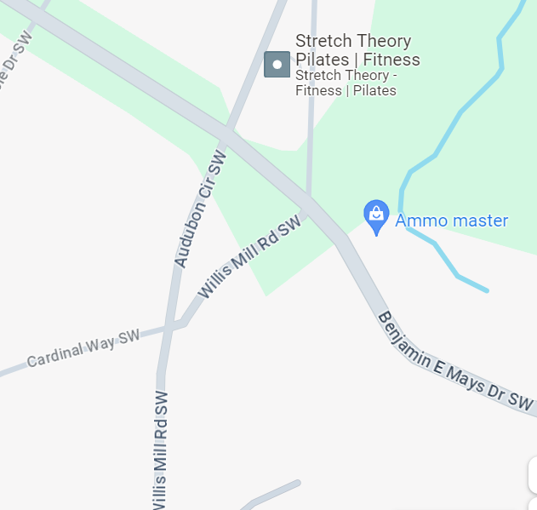

Left – Benjamin E Mays Dr

Left – Lynhurst Dr

Right – Cascade Rd

Regular Route

**EASTBOUND: From Kimberly Road Turnaround/Boat Rock Road & Reynolds Road To West End Station**

Continue – Cascade Rd

**BEGIN REROUTE**

Left – Lynhurst Dr

Right – Benjamin E Mays Dr

Right – Willis Mill Rd

Right – Audubon Cir

Continue Willis Mill Rd

Left – Cascade Rd

Regular Route